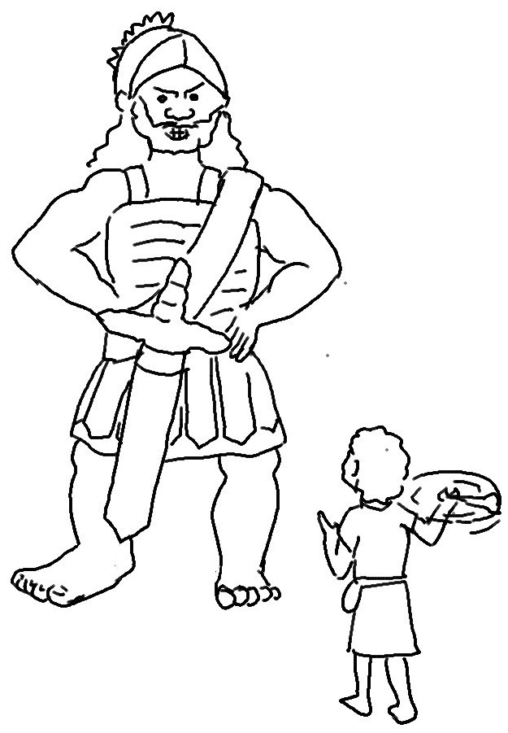
"You come to me with _ _ _ _ _, spear, and javelin, but I come to you in the name of the _ _ _ _…"
1 Samuel 17:45_{NLT}

